A Major Project On

## 3-D MEDICAL IMAGE SEGMENTATION

Submitted in partial fulfillment of the requirements for the award of the

## Bachelor of Technology

In

## Department of Computer Science and Engineering

By

|  |  |
| --- | --- |
| **T. Sai Chand** | **19241A05Z0** |
| **S. Vamshi** | **19241A05Z5** |
| **V.M. Mahith** | **202415A0533** |
| **S. Sanjay** | **202415A0532** |

Under the Esteemed guidance of

**Dr. Ashlin Deepa R.N**

**Associate Professor**

**Department of Computer Science and Engineering**

**GOKARAJU RANGARAJU INSTITUTE OF ENGINEERING AND TECHNOLOGY (Autonomous)**



**GOKARAJU RANGARAJU**

**INSTITUTE OF ENGINEERING AND TECHNOLOGY**

**(Autonomous)**

**CERTIFICATE**

This is to certify that the major project entitled “**3-D Medical Image Segmentation**” is submitted by **T. Sai Chand (19241A05Z0), S. Vamshi (19241A05Z5), V.M. Mahith (20245A0533), S. Sanjay (20245A0532)** in partial fulfillment of the award of degree in BACHELOR OF TECHNOLOGY in Computer Science and Engineering during academic year 2022-2023.

INTERNAL GUIDE HEAD OF THE DEPARTMENT

**Dr. Ashlin Deepa R.N Dr. K. MADHAVI**

**Associate Professor Professor**

EXTERNAL EXAMINER

# ACKNOWLEDGEMENT

There are many people who helped us directly and indirectly to complete our project successfully. We would like to take this opportunity to thank one and all. First we would like to express our deep gratitude towards our internal guide **Dr. Ashlin Deepa R.N, Associate Professor.** Department of CSE for his support in the completion of our dissertation. We wish to express our sincere thanks to **Dr. K. Madhavi, HOD, Department of CSE** and to our principal **Dr. J. Praveen** for providing the facilities to complete the dissertation. We would like to thank all our faculty and friends for their help and constructive criticism during the project period. Finally, we are very much indebted to our parents for their moral support and encouragement to achieve goals.

**T. Sai Chand (19241A05Z0)**

**S. Vamshi (19241A05Z5)**

**V.M Mahith (20245A0533)**

**S. Sanjay (20245A0532)**

# DECLARATION

We hereby declare that the industrial major project entitled **“3-D Medical Image Segmentation”** is the work done during the period from **16th Dec 2022 to 3rd June 2023** and is submitted in the partial fulfillment of the requirements for the award of degree of Bachelor of Technology in Computer Science and Engineering from Gokaraju Rangaraju Institute of Engineering and Technology (Autonomous under Jawaharlal Nehru Technology University, Hyderabad).The results embodied in this project have not been submitted to any other university or Institution for the award of any degree or diploma.

**T. Sai Chand (19241A05Z0)**

**S. Vamshi (19241A05Z5)**

**V.M Mahith (20245A0533)**

**S. Sanjay (20245A0532)**

|  |  |  |
| --- | --- | --- |
|  | **Table of Contents** |  |
| **Chapter** | **TITLE** | **Page No** |
|  | **Abstract** | **i** |
| **1** | **Introduction** | 8 |
|  | 1.1 Existing System | 9 |
|  | 1.2 Proposed System |  |
| **2** | **Literature Survey** | 10 |
| **3** | **Software Requirement Specifications** | 12 |
|  | **1.  Introduction** 3.1.1   Purpose of the requirements document 3.1.2   Scope of the product  **2.  General description** 3.2.1   Product perspective 3.2.2   Product functions 3.2.3   User characteristics 3.2.4   General constraints 3.2.5   Assumptions and dependencies  3. **Specific requirements**,: functional, non-functional and interface requirements. | 13  14  15 |
|  | 3.3 Feasibility Study | 17 |
|  | 3.3.1 Technical Feasibility |  |
|  | 3.3.2 Economic Feasibility |  |
|  | 3.3.3 Operational Feasibility |  |
| **4** | **Design** | 18 |
|  | 4.1 Project Description |  |
|  | 4.1.1 System Use case Diagrams |  |
|  | 4.1.2 Class Diagrams |  |
|  | 4.1.3 Data Flow Diagram(DFD) |  |
| **5** | **Implementation** | 21 |
|  | 5.1Source code  5.2 Screen shots |  |
| **6** | **Scope** | 34 |
| **7** | **References(Papers,Websites,Textboks)** |  |
| **8** | **List of Figures**   |  |  |  | | --- | --- | --- | | Figure No | Figure Title | Page No | | **Fig-4.1.1** | **Use Case Diagram** | 18 | | **Fig-4.1.2** | **Activity Diagram** | 19 | | **Fig- 4.1.3** | **Sequence Diagram** |  | | **Fig- 5.1.1** | **CT scan image** | 23 | | **Fig- 5.1.2** | **SqueezeNet model loss** | 29 | | **Fig- 5.1.3** | **ResNet model loss** | 29 | | **Fig- 5.1.4** | **Metric Dice coefficient score** | 30 | | **Fig- 5.1.5** | **No kidney Identified** | 31 | | **Fig- 5.1.6** | **Kidney Identified** | 31 | | **Fig- 5.1.7** | **Kidney along with segmented tumor** | 32 | |  |

Software Requirements Specifications Document

3.7.2 User Class

3.7.3 Objects

3.7.4 Feature

3.7.5 Stimulus

3.7.6 Response

3.7.7 Functional Hierarchy

Software Requirements Specifications Document

3.7.2 User Class

3.7.3 Objects

3.7.4 Feature

3.7.5 Stimulus

3.7.6 Response

3.7.7 Functional Hierarchy

**ABSTRACT**

Precise kidney and renal tumour segmentation is a crucial step for cutting-edge surgical planning techniques and radiomic analysis.A precise segmentation of the kidney and tumour using diagnostic pictures, such as those from computed tomography (CT) scans, is the cornerstone of efficient treatment.As a result, segmentation is crucial for establishing a link between the tumour and its surgical outcome and for helping doctors create more accurate treatment plans.The advancement of biomedical image segmentation algorithms has allowed us to obtain an accurate automated segmented mask.For the segmentation and creation of tumour output masks in this case, we are using ResNet and 3D U-Net.

**1. INTRODUCTION**

The growths in the kidneys known as kidney tumors (also known as renal tumors) can be benign or cancerous.The majority are unnoticed while you are being treated for another condition and do not result in symptoms.

The kidneys are organs in the abdomen that help the body maintain a healthy balance of chemicals like sodium, potassium, and calcium by removing waste and excess water from the blood and passing it out as urine.

Additionally, hormones produced by the kidneys encourage bone marrow to produce red blood cells and assist in blood pressure control.

A kidney tumor is considered to have kidney cancer if it is malignant.

Anemia, a lack of appetite, blood in the urine, lower back pain, and an unexpected weight loss are all signs of kidney cancer.

Skin cancer can also be caused by obesity. A side of the abdomen may bulge if the kidney has developed abnormally.

The risk of spreading to the entire kidney is very gradual due to their slow growth.

* 1. **Existing System**
* Chart

  Description automatically generatedThe current system used for kidney tumor segmentation is a manual process where radiologists and other medical professionals manually analyze medical images to identify tumors. This process is time-consuming and leads to unknown errors and delays in diagnosis and also in treatment. This process requires a high level of expertise, which can limit access to specialized care in some areas. The technical details of existing systems are mentioned briefly in the literature survey section but here we describe the primary backbone of image segmentation.

Fig 1 : architecture of U-net

* In existing methodologies, U net is most used algorithms for segmentation, the above diagram depicts the architecture of unet
* U-net is an extension of an encoder-decoder fully convolutional network .The intuition behind U-net is to encode the image passing it through a CNN as it gets downsampled and then decode it back or upsample it to obtain the segmentation mask. The features to be detected in the mask depends on the learned weight filters, up sampling & down sampling blocks and the concatenations & skip connections. The backbone is the architectural element which defines how these layers are arranged in the encoder network and they determine how the decoder network should be built.
* The backbone used are often Vanilla CNNs such as VGG, ResNet, Inception, EfficientNet etc which performs encoding and down sampling by itself. These networks are taken and their counter parts are built to perform decoding and up sampling to form the final Unet.
  1. **Proposed System**

To address the challenges faced by the existing system, a new system for kidney tumor segmentation will be developed. The proposed system will use advanced machine learning algorithms and artificial intelligence to automatically identify and segment tumors in medical images of the kidney. This will reduce the time and expertise required to perform tumor segmentation, this leads to faster and more accurate results. The proposed system will be able to analyze large amounts of data quickly with detailed information. Ultimately, the new system will improve patient outcomes by providing more efficient and accurate diagnosis and treatment for kidney tumors. We go into detail about the proposed method in this section. It includes the dataset's source, the model architecture, and the methods used to pre-process the data.

**Data Source :** All of the computed tomography scans were provided by the kidney tumor segmentation 2019 grand challenge, which was held at the Medical Image Computing and Computer Assisted Intervention conference (Miccai)[7]. The.nii.gz file extension is used to save the CT scans. The is typically where multidimensional neuroimaging data are kept. format NII (or NIfTI). The majority of packages also support reading zip-compressed NIfTI files, which should have the extension.NII.gz [8]. The 2D visualization of the 3D CT scan can be found here:

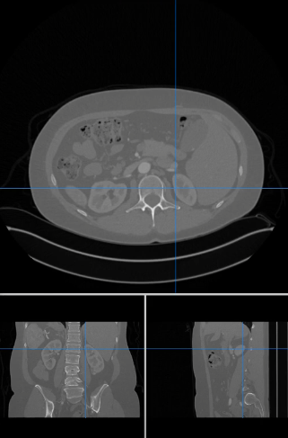

Fig 2: CT scan in .nii format

These files were processed with the help of the nibabel library. Data frames were made after libraries were imported, and a standard custom filter was used to make the component in the scan better. After that, the three-dimensional scans were broken up into two instances and saved as jpg files.

**Primary Model used:** Deep learning produces very significant outcomes when dealing with large datasets. Our model was built with squeezeNet and u-net learner. SqueezeNet is a convolutional neural network with 18 layers. The ImageNet database can be used to load a pretrained version of the network that has been trained on more than one million images. Images can be classified into one thousand object categories using the pretrained network, including keyboard, mouse, pencil, and numerous animals. The Fire module is the building block of SqueezeNet. It has two layers: a squeeze layer and an expand layer. A SqueezeNet is made up of stacked fire modules and pooling layers. The feature map size is the same for both the squeeze layer and the expand layer, with the squeeze layer decreasing the depth and the expand layer increasing it. The bottleneck layer (squeezing) and expansion behaviors are common in neural architectures. Another common pattern is to reduce the size of the feature map while increasing its depth[9] in order to achieve highlevel abstract. The following are included in a Fire module: an expand layer that feeds into a squeeze convolution layer and has a mix of 1x1 and 3x3 convolution filters. We gradually increase the number of Diagram
filters in each fire module from the beginning to the end of the network.

Fig 3 : the architecture of SqueezeNet

Following model fine-tuning, we used the Dice coefficient to evaluate the model. The dice score is the result of dividing the total number of pixels in the two images by twice the overlapped area. Dice score is the standard metric for image segmentation. Dice score is 2* area overlapped divided by total number of pixels in both images.

Fig 5 : visually depicting Dice coefficient

The primary reasons for choosing SqueezeNet and it’s way of making difference :

1. Small model size: SqueezeNet achieves its small size by replacing 3x3 filters in the network with 1x1 filters, which reduces the number of parameters in the model.
2. High accuracy: Despite its small size, SqueezeNet achieves accuracy comparable to much larger models. This is achieved by using fire modules, which have a combination of 1x1 and 3x3 filters, allowing for more complex features to be learned.
3. Low memory and processing requirements: SqueezeNet can be run on devices with limited memory and processing power, such as mobile phones and embedded devices, making it a useful architecture for real-time applications.
4. Fast training and inference: SqueezeNet can be trained and used for inference faster than larger models, making it a useful architecture for time-sensitive applications.
5. Versatility: SqueezeNet can be used for a wide range of tasks, including image classification, object detection, and semantic segmentation.

**2. LITERATURE STUDY**

**2.1 V-Nets**

* V-Net: It uses volumetric kernels of size 5*5*5 to perform convolution on each stage.
* The main advantage is that it can be used to segment 3D data.
* The impediment utilizing V-Net calculation is it calls for immense measure of investment to prepare the model.

**2.2 R-CNN**

* It extracts, or "region proposals," 2000 regions from the image using a selective search algorithm.
* It predicts whether an object will be present in the proposed region.
* It takes a significant amount of time to train a network to classify 2000 region suggestions per image.

**2.3 DeepLabV**

* The features from an image are extracted using atrous convolution.
* It works quickly because of atrous convolution.
* But because it uses CRFs here, the algorithm runs a little slower than it should.

**2.4 U-Net**

* Predict segmentation map is created by combining the contextual and location data from the upsampling path and the downsampling path.
* Using only a small number of labelled training images, it can effectively segment images.
* The maximum size of the input image is 572 x 572.The model's skip connections impose a restrictive fusion scheme, resulting in the accumulation of the same-scale network feature maps.

**2.5 CNN**

* It is made up of three primary neural layers: convolutional, pooling, and fully connected layers.
* It is straightforward and involves feeding the network segments of an image as input to label the pixels.
* It can't oversee different info sizes.

**3. SOFTWARE REQUIREMENT SPECIFICATION**

**3.1 Introduction**

**3.1.1 Purpose of the requirements document**

The purpose of the required document on kidney tumor segmentation is to provide an overview of the project, including its objectives, scope, methodology, and expected results.

* The document will provide an overview of the existing system and its limitations, as well as a detailed description of the proposed system and its expected benefits. This also defines specific techniques and algorithms that will be used to segment kidney tumors, and explains how the system will be validated and evaluated.
* Ultimately, the purpose of the document is to demonstrate the value and potential impact of the project and to facilitate its successful implementation.

**3.1.2 Scope of the Product**

• The scope of this product is to develop a computerized system for kidney tumor segmentation that uses advanced machine learning algorithms and artificial intelligence to automatically identify and segment tumors in medical images of the kidney.

* We are able to generate industry-standard metrics with more processing power or graphics processing units.We can use encoder networks that are more dense, combine data from multiple sources, or combine multiple networks.
* We can segment various tumors in the liver, lung, and brain using the same method.

**3.2.1 Definitions and abbreviations**

They are as follows

* **Numpy**

It adds support for large, multi-dimensional arrays and matrices, along with a large collection of high-level mathematical functions to operate on these arrays.

* **opencv**

Open CV is a python module or an open source library that is useful to understand the content of the digital images.

* **Pandas**

Pandas is a python module which is useful for analyzing, cleaning, exploring, and manipulating data present in out datasets.

* **Pip**

It is a package manager in python which helps to manage, install and update the required python packages and dependencies.

* **Matplotlib**

It is a plotting library for the python programming language and its numerical mathematics extension Numpy.

* **Tqdm**

tqdm is a package in python programming language used for progress metrics or a progress bars. This module also provides functions related to time.

* **Nibabel**

Nibabel is package in python which provides to access some common medical neuroimaging file formats.

* **Fastai**

fastai is a deep learning library which it provides practitioners and high level components and new data API. It is a call back system that can access any part of the data, it also acts as an optimizer.

**3.2 General Description**

**3.2.1 Product perspective**

The product perspective of the kidney tumor segmentation project involves identifying the system requirements, designing and developing the system, and testing and validating the system to ensure it meet the objectives.

From a functional perspective, the system will be designed to automatically identify and segment kidney tumors in medical images, providing accurate and reliable information on the size, shape, and location of tumors.

**3.2.2 Product functions**

The primary function of the kidney tumor segmentation system is to automatically identify and segment kidney tumors in medical images. To achieve this, the system will incorporate advanced machine learning and artificial intelligence algorithms to analyze medical images and identify regions of interest corresponding to tumors**.**

The specific functions of the system include:

* Image pre-processing
* Feature extraction
* Tumor segmentation
* Visualization

**3.2.3 User characteristics**

The kidney tumor segmentation system will primarily be used by medical field such as radiologists, oncologists, and urologists who specialize in the diagnosis and treatment of kidney tumors.

Therefore, the following are the characteristics:

* Medical expertise
* Technical proficiency
* Adaptability
* Collaboration

**3.2.4 General constraints**

There are few general constraints that must be considered in the development and implementation of a kidney tumor segmentation system:

Regulatory compliance: The system must comply with relevant regulatory requirements for medical devices and software, including any applicable standards for safety and efficiency.

Data privacy and security: The system must protect patient data and ensure the privacy and security of sensitive medical information.

Technical limitations: The accuracy and performance of the system may be limited by factors such as hardware capabilities, software algorithms, and data quality.

Integration with existing systems: The system must be compatible with existing medical imaging and patient management systems to facilitate efficient workflows and minimize disruptions to clinical operations.

Cost-effectiveness: The development and implementation of the system must be cost-effective, taking into account factors such as equipment, software, personnel, and maintenance costs.

**3.2.5 Assumptions and Dependencies**

Assumptions:

* The system assumes that the medical images used for segmentation are of high quality and provide accurate and reliable information about the kidney tumors.
* The system assumes that the users have adequate knowledge and training on medical imaging and the use of the system.
* The system assumes that there are no major hardware or software issues that could significantly impact the accuracy or performance of the system.

Dependencies:

* The system is dependent on the availability of high-quality medical imaging equipment and software.
* The system is dependent on the availability of trained medical professionals who can interpret and use the segmentation results.
* The system is dependent on the availability of patient data and relevant medical information.
* The system is dependent on the availability of appropriate regulatory approvals and compliance with relevant standards and guidelines.

**3.3 Specific Requirements**

Functional Requirements:

* The system should accept medical images of the kidneys as input for tumor segmentation.
* The system should accurately identify and segment kidney tumors in medical images.
* The system should allow users to view and edit segmentation results.
* The system should generate reports on tumor characteristics and location.
* The system should provide visualization tools to help users interpret segmentation results.

Non-functional Requirements:

* Accuracy: The system must have a high level of accuracy in identifying and segmenting kidney tumors.
* Performance: The system must be able to process images and provide segmentation results quickly and efficiently.
* Reliability: The system must be reliable and operate without errors or interruptions.
* Security: The system must ensure the security and privacy of patient data and comply with relevant regulations and standards.
* Usability: The system must be user-friendly and easy to use for medical professionals with varying levels of technical expertise.
* Interoperability: The system must be compatible with existing medical imaging and patient management systems to facilitate efficient workflows and minimize disruptions to clinical operations.

**3.3.Feasibility Study**

A feasibility study is an important step in determining the viability of a project, and it can help identify potential risks and opportunities.

**Technical Feasibility:** Based on the current state of medical imaging technology and machine learning algorithms, it is technically feasible to develop a kidney tumor segmentation system that can accurately identify and segment tumors in medical images.

**Economic Feasibility**: The development and implementation of a kidney tumor segmentation system may involve costs that includes hardware and software expenses, development costs, and ongoing maintenance and support expenses.

**Operational Feasibility**: The success of a kidney tumor segmentation system will depend on its integration with existing medical imaging and patient management systems, as well as its ease of use for medical professionals. Therefore, it is important to ensure that the system is designed to be compatible with existing workflows and that it is user-friendly and easy to operate.

**4. DESIGN**

**4.1**. **Project Description**

The project aims to develop a kidney tumor segmentation system that can accurately identify and segment tumors in medical images. This will help medical professionals to make more informed diagnoses and treatment decisions, leading to improved patient outcomes and reduced healthcare costs.

The project will involve several key steps, including data collection and preprocessing, algorithm development and training, system design and implementation, and testing and evaluation. The system will be evaluated based on its accuracy, speed, and usability, and any necessary adjustments or improvements will be made to ensure its effectiveness.

**4.1.1 Use Case Diagram**

Basically, A usecase diagram is representation of actors that interact with usecase. These diagrams represents the relations between various components of the program. It renders using usecases and actors involved in it.

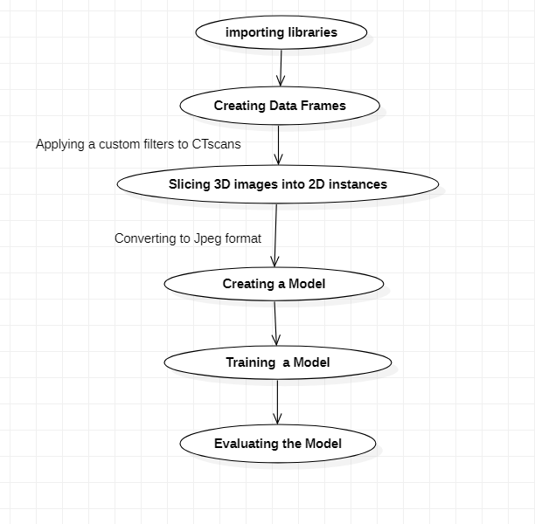

**Fig-4.1.1 Use Case Diagram**

**4.1.2 Activity Diagram**

The activities are represented in a step-by-step process in an activity diagram. An activity diagram is essentially a structural outline of a system that depicts the progression of a task from one to another.

The following activity diagram shows thirteen identified tasks that are combined with constraints. After loading the dataset and creating data frames, CT scans will be filtered and 3D images will be sliced into 2D instances. After it has been made into a jpeg file. The model will then be trained with SqueezeNet, U-Net, and ResNet algorithms.

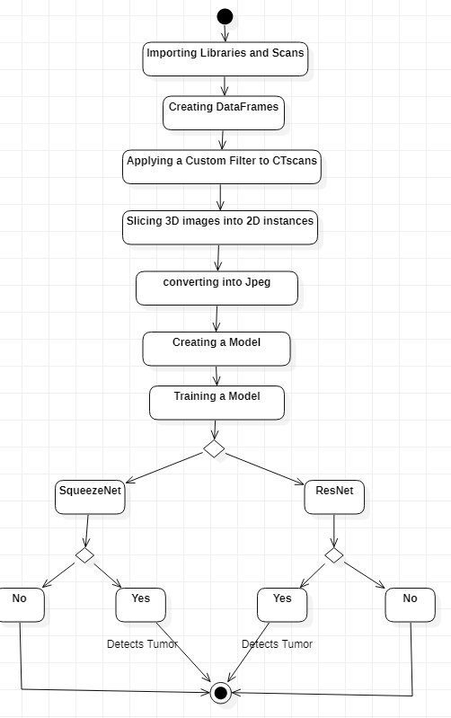

**Fig- 4.1.2. Activity Diagram**

**4.1.3 Sequence Diagram**

The interactions between the objects are shown using a sequence diagram.

In underneath chart, there are three life savers in particular tolerant, nephrologist and the model. The lifelines facilitate communication between the patient and the nephrologist.

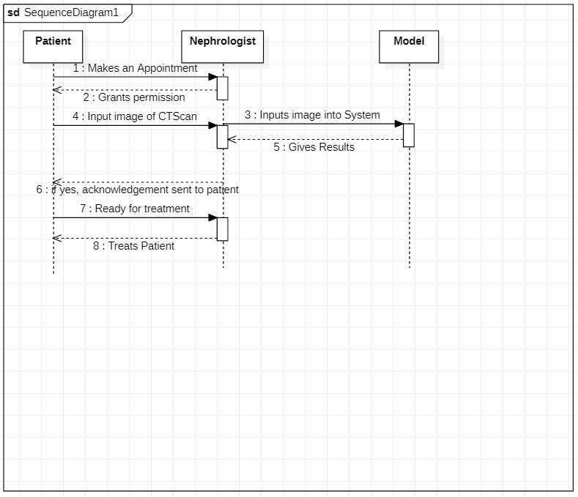

**Fig-4.1.3 Sequence Diagram**

**5. IMPLEMENTATION**

**5.1 Source Code**

**5.1.1 Importing Libraries**

Here are the following libraries used in our project.

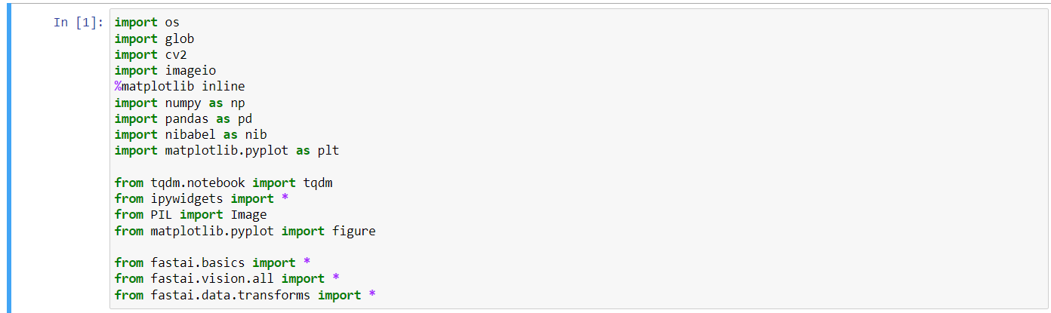

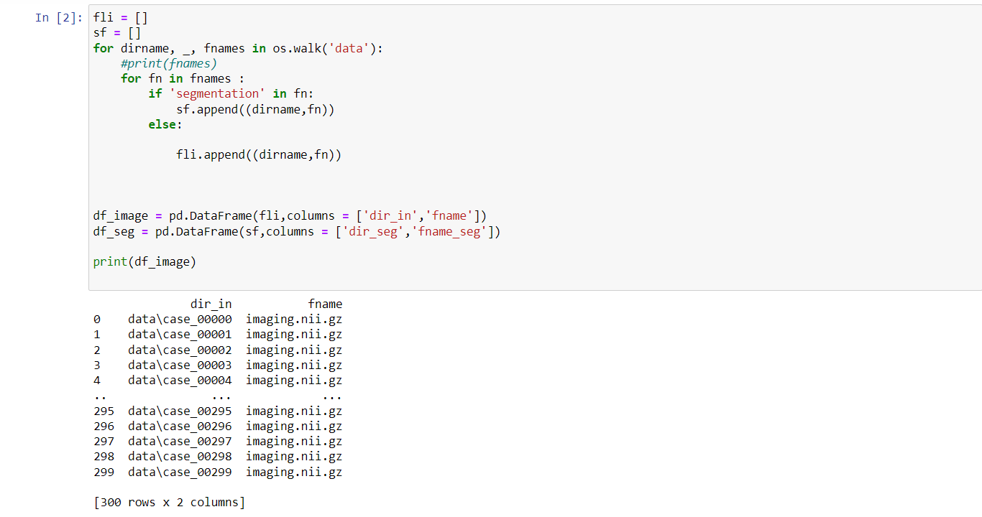

**5.1.2 Creating data frame**

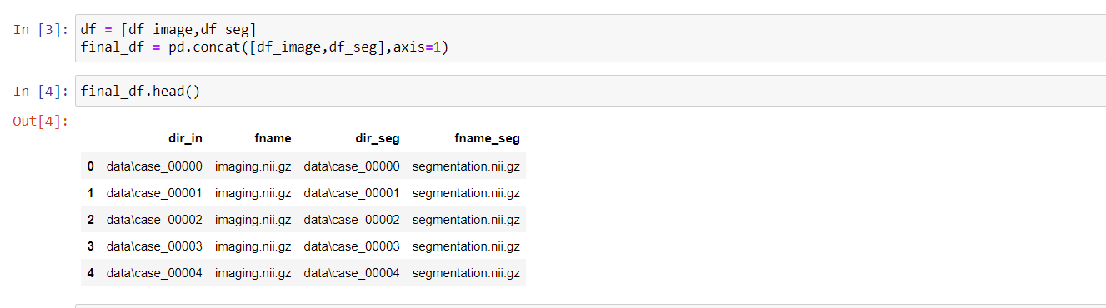

**5.1.3 Creating a custom filter to enhance computed tomography scan image**

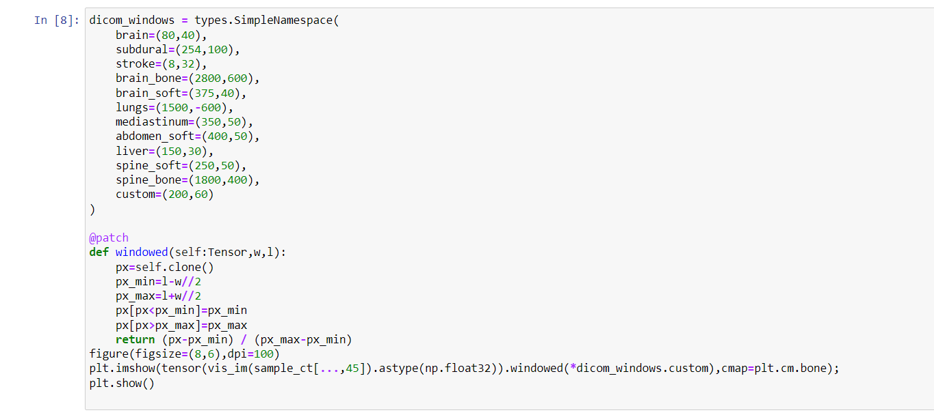

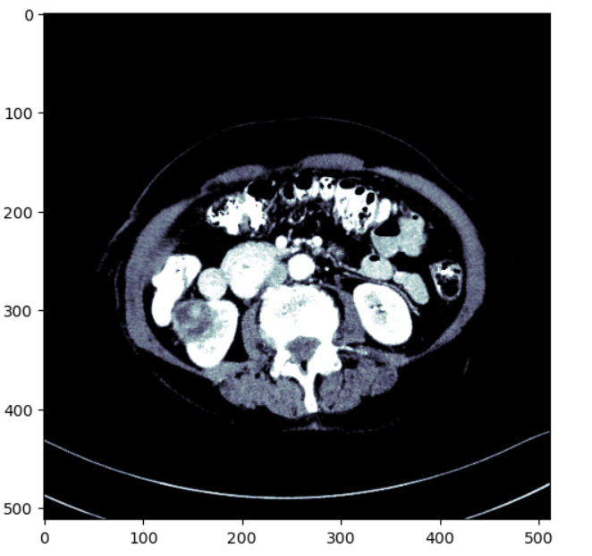

**Fig-5.1.1 CT Scan Image**

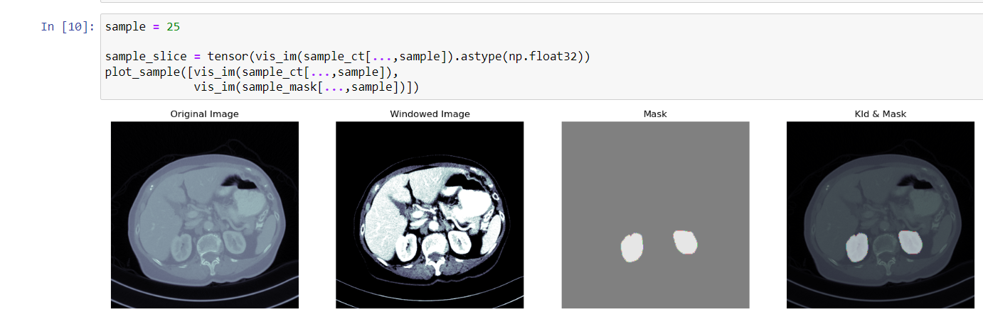

**5.1.4 slicing images and converting them into jpg**

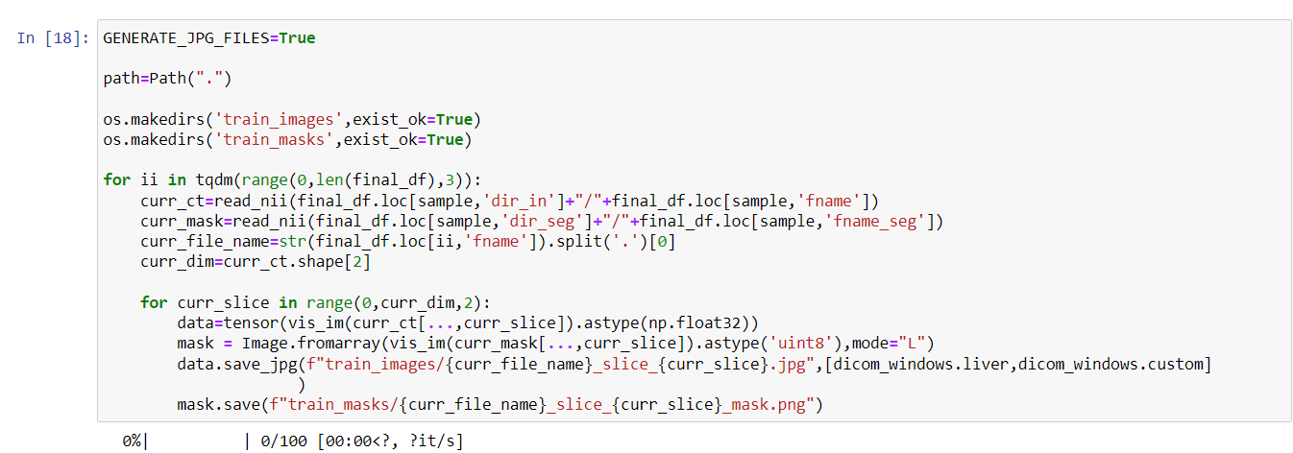

**5.1.5 loading data using dataloader**

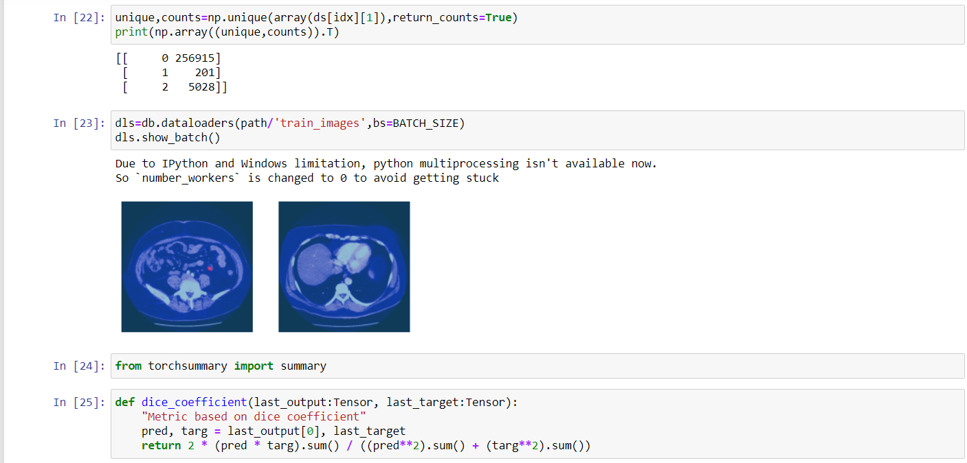

**5.1.6 Creating and fine-tuning model**

**Model-1**



**Model-2**

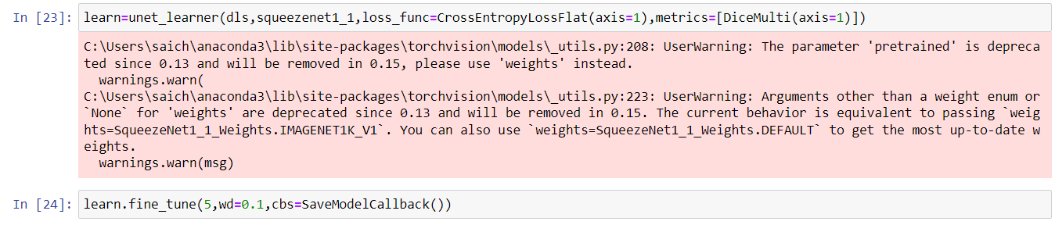

**Model-1 Results**

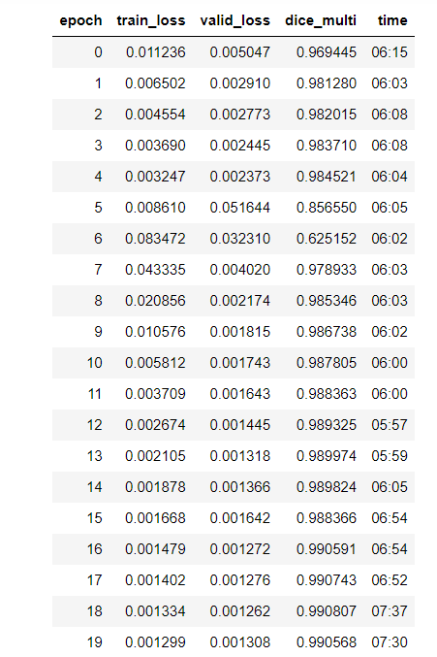

**Model-2 Results**

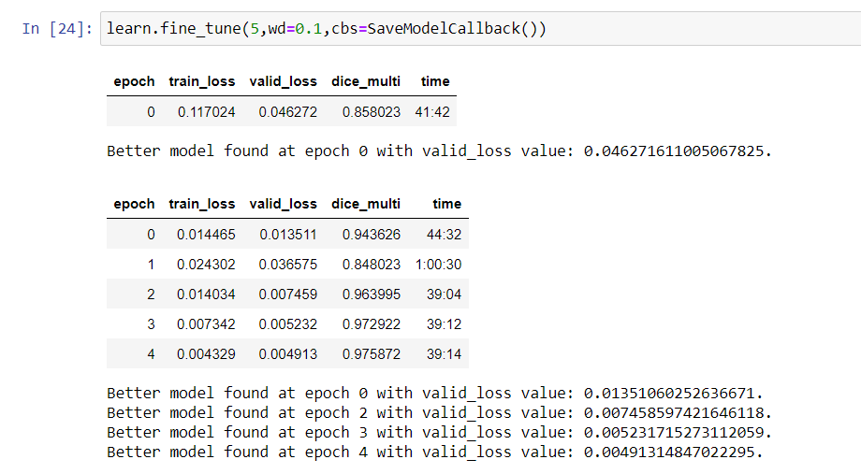

**Loss**

**SqueezeNet Model**

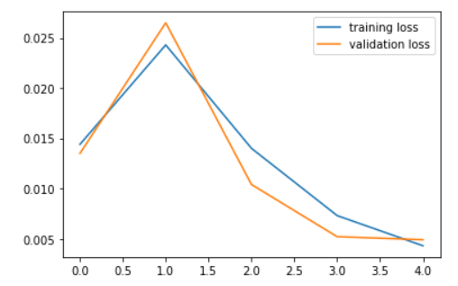

**Fig-5.1.2 SqueezeNet model loss**

**ResNet Model**

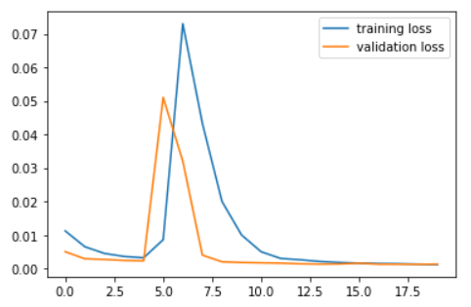

**Fig-5.1.3 Resnet model loss**

**Metric- Dice Coefficient**

Simply put, the Dice Coefficient is 2 * the Area of Overlap divided by the total number of pixels in both images.

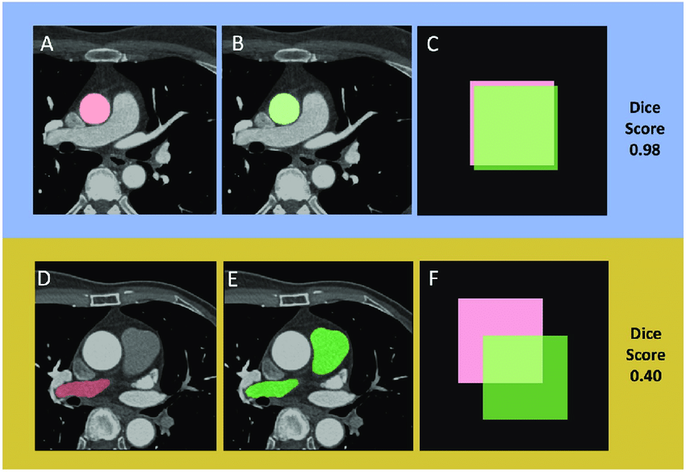

**Fig-5.1.4 Metric Dice Coefficient score**

**No Kidney Identified**

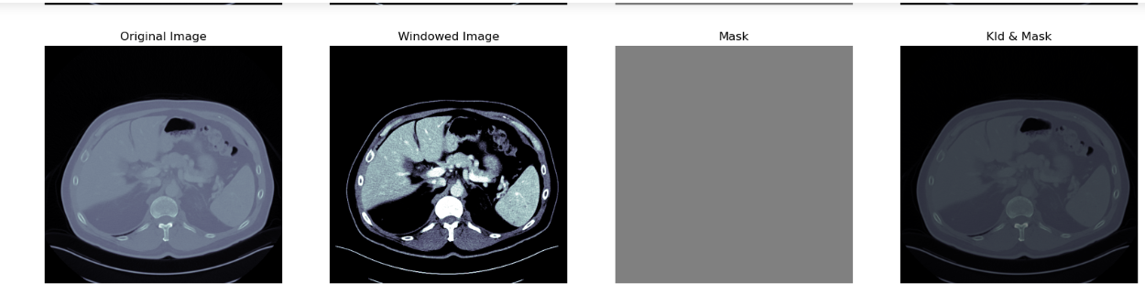

**Fig-5.1.5 No Kidney Identified**

**Kidney Identified**

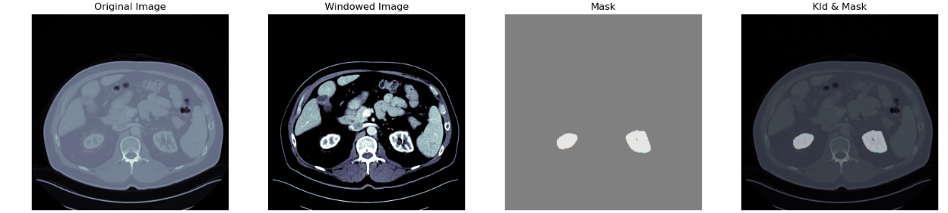

**Fig-5.1.6 Kidney Identified**

**Kidney Along with Segmented Tumor**

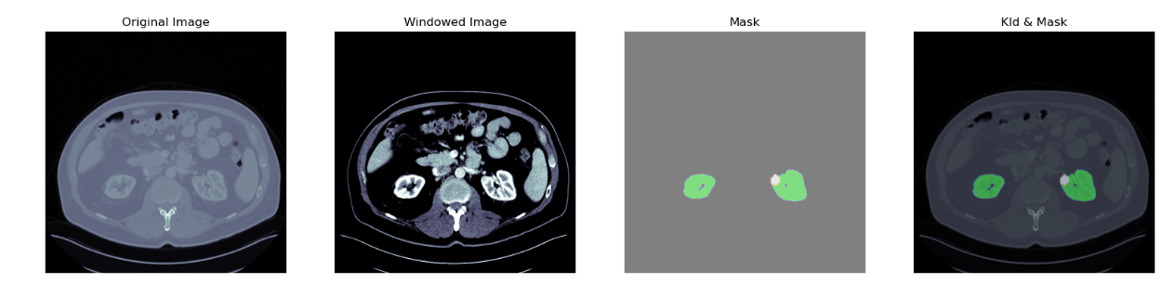

**Fig-5.1.7 Kidney along with segmented tumor**

**6. SCOPE**

* The scope of this product is to develop a computerized system for kidney tumor segmentation that uses advanced machine learning algorithms and artificial intelligence to automatically identify and segment tumors in medical images of the kidney.
* We are able to generate industry-standard metrics with more processing power or graphics processing units. We can use encoder networks that are more dense, combine data from multiple sources, or combine multiple networks.
* We can segment various tumors in the liver, lung, and brain using the same method.

**7. REFERENCES**

[1] National kidney foundation https://www.kidney.org/atoz/content/- kidney-cancer

[2] American cancer society https://www.cancer.org/cancer/kidneycancer/about/what-is-kidney-cancer.html

[3] Qin, Dian & Bu, Jiajun & Liu, Zhe & Shen, Xin & Zhou, Sheng & Jingjun, Gu & Wang, Zhijua & Wu, Lei & Dai, Huifen. (2021). Efficient Medical Image Segmentation Based on Knowledge Distillation.

[4] P. Bilic, et al., “The Liver Tumor Segmentation Benchmark (LiTS),” 2019, arXiv:1901.04056. [Online]. Available:https://arxiv.org /abs/ 1901.04056

[5] N. Heller, et al., “The KiTS19 Challenge Data: 300 Kidney Tumor Cases with Clinical Context, CT Semantic Segmentations, and Surgical Outcomes,” 2019, arXiv:1904.00445. [Online]. Available: https:/- /arxiv.org/abs/1904.00445

[6] Iandola, F. N., Moskewicz, M. W., Ashraf, K., Han, S., Dally, W. J., & Keutzer, K. (2016). SqueezeNet: AlexNet-level accuracy with 50x fewer parameters and <1MB model size. CoRR, abs/1602.07360.

[7] Grand Challenge <https://kits19.grand-challenge.org/>

[8] Brainder <https://brainder.org/2012/09/23/the-nifti-file-format/>

[9] Squeeze net https://medium.com/@smallfishbigsea/notes-ofsqueezenet-4137d51feef4

[10] Kaiming He Georgia Gkioxari Piotr Dollar Ross Girshick ´ Facebook AI Research (FAIR)

[11] Robert J Gillies, Paul E Kinahan, and Hedvig Hricak. Radiomics: images are more than pictures, they are data. Radiology, 278(2):563– 577, 2016.

[12] Xiao- Xia Yin , 1,2 Le Sun,3 Yuhan Fu,1 Ruiliang Lu,4 and Yanchun Zhang 1

[13] Patrick Ferdinand Christ, Florian Ettlinger, Felix Grun , Mohamed ¨ Ezzeldin A Elshaera, Jana Lipkova, Sebastian Schlecht, Freba Ahmaddy, Sunil Tatavarty, Marc Bickel, Patrick Bilic, et al. Automatic liver and tumor segmentation of ct and mri volumes using cascaded fully convolutional neural networks. arXiv preprint arXiv:1702.05970, 2017.

[14] Liang- Chieh Chen, George Papandreou, Iasonas Kokkinos, Kevin Murphy, Alan L. Yuille

[15] Sanjay Kumar1, Naresh Kumar2, Rishabh3, Inderpreet Kaur4, Vivek Keshari1

[16] Fausto Milletari 1 , Nassir Navab 1 , 2 , Seyed-Ahmad Ahmadi 3 1 Computer Aided Medical Procedures, Technische Universit¨at M¨unchen, Germany 2 Computer Aided Medical Procedures, Johns Hopkins University, Baltimore, USA 3 Department of Neurology, Klinikum Grosshadern, Ludwig-Maximilians-Universit¨at M¨unchen, Germany

[17] G. Litjens, T. Kooi, B. E. Bejnordi, A. A. A. Setio, F. Ciompi, M. Ghafoorian, J. A. van der Laak, B. V. Ginneken, and C. I. Sanchez, ´ “A survey on deep learning in medical image analysis,” Medical Image Analysis, vol. 42, pp. 60–88, 2017.

[18] F. Zhao and X. Xie, “An overview of interactive medical image segmentation,” Annals of the BMVA, vol. 2013, no. 7, pp. 1–22, 2013